Symbiosis Institute of Technology, Pune

Department of Electronics & Telecommunications
First Year B. Tech Academic Year: 2025-26

Olympics Data Analysis
By:
- Falak Jain (25070123047)
- Gunjan Goyal (25070123048)
- Hiranya Bedi (25070123054)
- Jahnvi Shukla (25070123055)

Faculty In-Charge: Dr Snehal Bhosle

ACKNOWLEDGEMENT

We are deeply thankful to our EDA Teacher, Dr Snehal Bhosle, for her continuous and unwavering support throughout the completion of this Python-based data analysis project. Her timely guidance, constructive feedback, and in-depth domain knowledge were invaluable in shaping the direction and quality of our work. Every discussion we had with him resulted in a clearer understanding of both the analytical concepts and their real-world applications in sports data science.

We want to extend our sincere gratitude to the Symbiosis Institute of Technology and its administration for providing us with the necessary infrastructure, computing resources, and learning environment required to undertake a project of this scale. Access to Python environments, data processing tools, and reference material in the college library made a significant difference in our research process.

We are also grateful to our peers and fellow students who volunteered their time for peer-review sessions and offered suggestions that helped deepen our analysis. Our parents deserve special acknowledgement for their moral support and encouragement during long working hours dedicated to cleaning, processing, and visualising the data.

Finally, we acknowledge the open-source communities behind the Python libraries Pandas, NumPy, Matplotlib, and Seaborn, as well as the providers of the public Olympics datasets from Kaggle (athlete_events.csv and country_economics.csv). Without these freely available resources, this project would not have been possible.

INTRODUCTION

The Olympic Games represent one of the most comprehensive and globally inclusive sporting events in human history. Since their modern revival in Athens in 1896, the Games have grown from a modest gathering of a few hundred athletes to a multi-billion-dollar event featuring over ten thousand participants from more than two hundred countries. This evolution offers an extraordinary opportunity for data-driven analysis — not only of athletic performance, but also of broader socio-economic, political, and demographic trends.

In our EDA project, we analyse historical Olympics data spanning from 1896 to 2016. The dataset includes athlete-level records covering physical attributes (age, height, weight), medal outcomes, event-level participation, and country-level economic indicators such as GDP per capita and population. By combining data from two sources — athlete_events.csv (271,116 rows) and country_economics.csv (201 country records) — we perform end-to-end data analysis using Python.

The project begins with raw, uncleaned data containing missing values, duplicate records, and unstructured fields. Through systematic data cleaning, feature engineering, and exploratory analysis, we transform this raw data into meaningful insights. Essential Python libraries such as Pandas for data manipulation, NumPy for numerical operations, Matplotlib for charting, and Seaborn for statistical visualisation are utilised throughout the project.

Charts, trend analyses, statistical summaries, and economic comparisons are employed to illustrate performance patterns, gender equality trends, physical profile distributions, and the relationship between a country's economic strength and its Olympic success. The project concludes with actionable policy recommendations aimed at improving sporting investment and athlete welfare — particularly in lower-income countries that remain underrepresented on the Olympic podium.

This project demonstrates how Python's powerful data analysis ecosystem, when applied thoughtfully to large real-world datasets, can produce insights that go far beyond what manual inspection could ever achieve. It also highlights the importance of clean data, careful feature engineering, and clear visualisation in communicating findings to a non-technical audience.

OBJECTIVE OF THE PROJECT

The primary aim of this project is to perform a comprehensive data analysis of the Olympic Games dataset, extracting meaningful patterns and trends that can inform sports management, policy, and research. The specific objectives are as follows:

- Participation Analysis for 1896–2016: Compile athlete-level records and summarise overall participation trends including gender representation over time, athlete counts per year, sport-wise distribution of entries, and the evolution of Summer vs. Winter Games in terms of scale and diversity.
- Medal Assessment by Country and Year: Determine periods of peak national performance and identify areas of improvement by analysing each country's medal tallies (Gold, Silver, Bronze) across seasons, decades, and different political eras, such as before and after the Cold War.
- Understanding Individual Athlete Profiles: Examine physical data for every participating athlete to identify typical body profiles, compare male vs. female athletes, and understand how age, height, weight, and BMI vary across sports. Determine which sports favour which physical attributes.
- Understanding Country Olympic Profiles: Evaluate each nation's Olympic track record against economic and demographic factors such as GDP per capita and population. Understand why some smaller, wealthier nations consistently outperform larger, less wealthy ones on a per-athlete basis.
- Economic and Demographic Correlations: Investigate the relationship between a country's economic tier (Low, Lower-Mid, Upper-Mid, High GDP) and its total medal count and medal efficiency rate. Use bubble chart visualisation to simultaneously map GDP, medals, and population.
- Gender Equality Trend Analysis: Track the progression of female participation in the Olympics from near-zero in 1896 to approaching parity by 2016. Analyse which sports were earliest to include female events and which remain male-dominated.
- Thorough Data Insights and Policy Recommendations: Synthesise all findings into actionable suggestions for improving sports investment strategies, athlete health monitoring, and inclusion policies — aimed at sports governing bodies, national Olympic committees, and governments.

RAW DATA

The project relies on two primary datasets sourced from publicly available repositories. Together, they provide both the micro-level athlete data and the macro-level country economic context needed for a comprehensive analysis.

Dataset 1: athlete_events.csv
This dataset contains one row per athlete per event per Olympic Games, spanning the period from 1896 to 2016. With 271,116 total rows and 15 columns, it is the core dataset for all athlete-level and medal-level analysis. Each entry captures the identity, physical attributes, and performance outcome of a single athlete in a single event.

Column | Data Type | Description | Missing Values
ID | Integer | Unique athlete identifier | 0
Name | String | Athlete's full name | 0
Sex | String | M / F | 0
Age | Float | Age at time of Games | 9,474 (3.49%)
Height | Float | Height in centimetres | 60,171 (22.19%)
Weight | Float | Weight in kilograms | 62,875 (23.19%)
Team | String | Country/team name | 0
NOC | String | National Olympic Committee code | 0
Games | String | Year + Season label | 0
Year | Integer | Olympic year | 0
Season | String | Summer / Winter | 0
City | String | Host city | 0
Sport | String | Sport name | 0
Event | String | Specific event | 0
Medal | String | Gold / Silver / Bronze / NaN | 231,333 (85.33%)

Dataset 2: country_economics.csv
This dataset provides country-level economic and demographic data for 201 nations/territories. It is used to contextualise Olympic performance against economic strength. Eight entries are marked with asterisks (*), indicating they are dependent territories rather than sovereign states.

Column | Data Type | Description | Missing Values
Country | String | Full country / territory name | 0
Code | String | 3-letter NOC / ISO code | 0
Population | Float | Total population (2015 approx.) | 5 (2.49%)
GDP per Capita | Float | GDP per capita in USD | 25 (12.44%)

Sport-wise Entry Distribution — Top 10 Sports
The athlete events dataset spans 66 unique sports. Athletics (track & field) accounts for the largest share of entries, followed by Swimming and Gymnastics. The table below shows the approximate entry counts for the ten most represented sports.

Rank | Sport | Approx. Entries | % of Total
1 | Athletics | 38,624 | 14.26%
2 | Swimming | 24,228 | 8.94%
3 | Gymnastics | 20,853 | 7.70%
4 | Shooting | 15,601 | 5.76%
5 | Cycling | 13,919 | 5.14%
6 | Rowing | 13,674 | 5.05%
7 | Wrestling | 11,765 | 4.34%
8 | Fencing | 10,312 | 3.80%
9 | Football (Soccer) | 9,801 | 3.62%
10 | Sailing | 8,439 | 3.11%

GDP Tier Distribution of Countries
Countries in the dataset are spread across four GDP tiers. The majority fall into the Lower-Mid category, reflecting the global income distribution. High-income nations are the fewest in count but dominate the Olympic medal table.

GDP Tier | GDP Range (USD) | No. of Countries | % of Dataset
Low | < $2,000 | ~40 | 19.9%
Lower-Mid | $2,000 – $10,000 | ~70 | 34.8%
Upper-Mid | $10,000 – $30,000 | ~53 | 26.4%
High | > $30,000 | ~38 | 18.9%

LIBRARIES AND FUNCTIONS USED

Python's data analysis ecosystem is one of the most powerful and versatile toolkits available for working with large datasets. It allows for automated, reproducible, and scalable analysis. The following libraries and key functions were used extensively throughout this project.

1. Pandas — Data Manipulation
Pandas is the foundational data manipulation library in Python. It introduces the DataFrame — a two-dimensional, labelled data structure analogous to a spreadsheet that allows intuitive slicing, grouping, merging, and transformation of data.

Function / Method | Purpose | Used For
pd.read_csv() | Load data from CSV file into a DataFrame | Loading both datasets
df.isnull().sum() | Count missing values column-wise | Data quality report
df.duplicated().sum() | Count exact duplicate rows | Duplicate detection
df.drop_duplicates() | Remove duplicate rows | Cleaning athlete data
df.fillna(value) | Fill missing values with a specified value | Medal NaN → 'No Medal'
df.groupby().agg() | Group rows and apply aggregate functions | NOC medal summaries
pd.cut() | Bin continuous values into discrete intervals | GDP tier categorisation
df.merge() | Join two DataFrames on a key column | Merging NOC data with country data
df.value_counts() | Count frequency of unique values | Sport/medal frequency
df.nunique() | Count unique values per column | Quality report stats

2. NumPy — Numerical Operations
NumPy provides the numerical backbone for Python data science. It offers fast array operations and mathematical functions used for derived feature calculation and outlier detection.

Function | Purpose | Used For
np.log10() | Compute base-10 logarithm | Log-scale population for bubble chart
np.inf | Represent infinity | Upper bound of GDP tier bins
np.sqrt() | Square root | Scaling bubble sizes by population
np.arange() | Create evenly spaced arrays | X-axis positions in bar charts

3. Matplotlib — Data Visualisation
Matplotlib is Python's primary plotting library, offering fine-grained control over charts and figures. All charts in this project were generated using Matplotlib, often with customised labels, colour schemes, and layout configurations.

- plt.subplots() — Create figure with one or more axes panels for multi-chart layouts
- ax.hist() — Plot frequency histograms for physical attribute distributions
- ax.bar() / ax.barh() — Vertical and horizontal bar charts for medal counts and sport entries
- ax.pie() — Pie chart for medal type proportion among winners
- ax.plot() — Line charts for time-series gender and medal trend analysis
- ax.scatter() — Scatter/bubble chart for GDP vs. medals economic analysis
- ax.stackplot() — Stacked area chart for cumulative gender participation
- ax.axhline() / ax.axvline() — Reference lines (e.g., 50% parity line, mean line)
- ax.annotate() — Label standout data points such as top-performing countries
- plt.savefig() — Export charts as PNG files for inclusion in reports

4. Seaborn — Statistical Visualisation
Seaborn is built on top of Matplotlib and provides higher-level interfaces for drawing attractive statistical graphics. It was used for colour palettes and specific chart types requiring statistical clarity.

- sns.color_palette() — Generate distinguishable colour sets for multi-line charts
- sns.color_palette('tab20') — 20-colour palette for top-20 sport bar chart

5. Data Analysis Techniques
Beyond individual functions, the following analytical techniques were applied as core components of the project methodology:

Technique | Description | Applied To
Median Imputation | Replace missing values with the column median to minimise distortion | Age, Height, Weight, GDP, Population
Group Median Imputation | Impute within subgroups (territory vs. country) for context-sensitive replacement | GDP per Capita missing values
IQR Outlier Detection | Flag values beyond Q1 − 1.5×IQR or Q3 + 1.5×IQR as potential outliers | Athlete age distribution
Feature Engineering | Create new columns from existing data to enable richer analysis | BMI, Won_Medal, GDP_Tier, Log_Population, Medal_Rate
Pivot / Unstacking | Reshape grouped data into wide format for time-series and comparison charts | Gender by year, medals by NOC
Bubble Chart Encoding | Encode a third variable (population) as marker size in a scatter plot | GDP × Medals × Population chart
Stacked Area Chart | Show part-to-whole composition over time | Gender participation trends

DATA CLEANING & PREPARATION

Raw data rarely arrives in a form ready for analysis. Both datasets used in this project contained missing values, inconsistencies, and unstructured fields that required systematic cleaning before any meaningful analysis could begin. The cleaning pipeline was designed to be transparent, reproducible, and conservative — avoiding data removal where imputation was a reasonable alternative.

Cleaning the Country Dataset (country_economics.csv)
Step 1 — Territory Flagging & Cleaning
Detected asterisks (*) to identify dependent territories, created an Is_Territory flag (1 = territory, 0 = country), and removed asterisks from names.
Result: 8 territories identified (e.g., American Samoa, Aruba); names standardized.
Step 2 — Population Imputation
5 countries (2.49%) had missing population values. Filled using the median to avoid skew from very large countries.
Imputed value: 7,450,124.
Step 3 — GDP per Capita Imputation
25 countries (12.44%) had missing values. Imputed separately for countries and territories to reduce bias.
Group | Missing Count | Imputed Median GDP | Rationale
Sovereign Countries | ~17 | $5,232.02 | Reflects typical developing-nation income
Territories | ~8 | $42,327.84 | Territories tend to be wealthy (e.g., overseas departments of France, Netherlands)

Step 4 — Feature Engineering
Added two features:
• GDP Tier: Categorized GDP per capita into Low, Lower-Mid, Upper-Mid, High using defined bins.
• Log Population: Applied log₁₀ to population to reduce scale variation.
Final State: No missing values across 201 rows and 6 columns.

Cleaning the Athlete Dataset (athlete_events.csv)
Step 1 — Duplicate Removal
Removed 1,385 exact duplicate rows and reset the index.
Result: 271,116 → 269,731 rows.
Step 2 — Medal NaN Handling
Filled 231,333 missing values (85.33%) with “No Medal”, as they represent non-medallists.
Step 3 — Physical Attribute Imputation
Imputed missing Age (3.49%), Height (22.19%), and Weight (23.19%) using median to reduce outlier impact.

Column | Missing Count | Missing % | Imputed Value (Median)
Age | 9,474 | 3.49% | 24.0 years
Height | 60,171 | 22.19% | 175.0 cm
Weight | 62,875 | 23.19% | 70.0 kg
Step 4 — Feature Engineering
Added:
• BMI: Calculated as weight/height² for body composition comparison.
• Won Medal: Binary flag (1 = medal, 0 = none) for easy analysis.
Step 5 — Age Outlier Detection
Used IQR (Q1 = 20, Q3 = 28) → flagged ages < 8 or > 40.
11,059 records flagged (ages 10–97), but retained as valid cases.
Final State: 269,731 rows × 17 columns, no missing values.
EXPLORATORY DATA ANALYSIS (EDA)

Exploratory Data Analysis is the process of visually and statistically summarising the main characteristics of a dataset before formal modelling. In this project, EDA was used to understand the distribution of physical attributes, medal outcomes, and participation patterns across sports, genders, and nations.
5.1 Athlete Physical Attribute Distributions
Histograms were generated for Age, Height, Weight, and BMI using 40-bin charts with mean (dashed black) and median (dotted grey) reference lines overlaid. The findings are:

Mean | Median | Distribution Shape | Notable Observation
25.4 yrs | 24.0 yrs | Right-skewed | Most athletes compete in their early-to-mid twenties; a long tail extends to age 97
175.4 cm | 175.0 cm | Approximately normal | Male athletes average ~179cm; female athletes average ~167cm
70.5 kg | 70.0 kg | Right-skewed | Most athletes are lean; heavyweight sports (weightlifting, judo) pull the tail right
22.8 | 22.86 | Normal (trimmed) | Peak at 22–24; extreme BMI values trimmed to range 15–50 for clarity
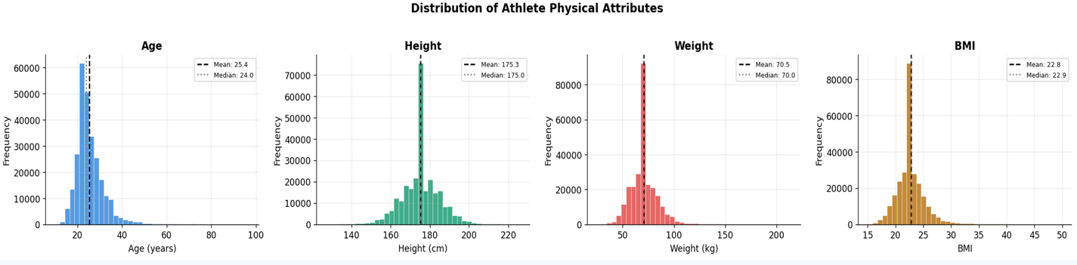
5.2 Medal Category Breakdown
Of the 269,731 cleaned athlete entries, medals were awarded in approximately 14.67% of cases. This is consistent with the Olympic structure, where three medals are awarded per event and most participants do not medal. A bar chart was used to show absolute medal counts, and a pie chart was used to show the proportional split among medal winners only.

Medal Type | Approx. Count | % of All Entries | % of Medal Winners Only
Gold | ~13,116 | ~4.87% | ~33.3%
Silver | ~13,116 | ~4.87% | ~33.3%
Bronze | ~13,116 | ~4.87% | ~33.3%
No Medal | ~230,383 | ~85.33% | N/A
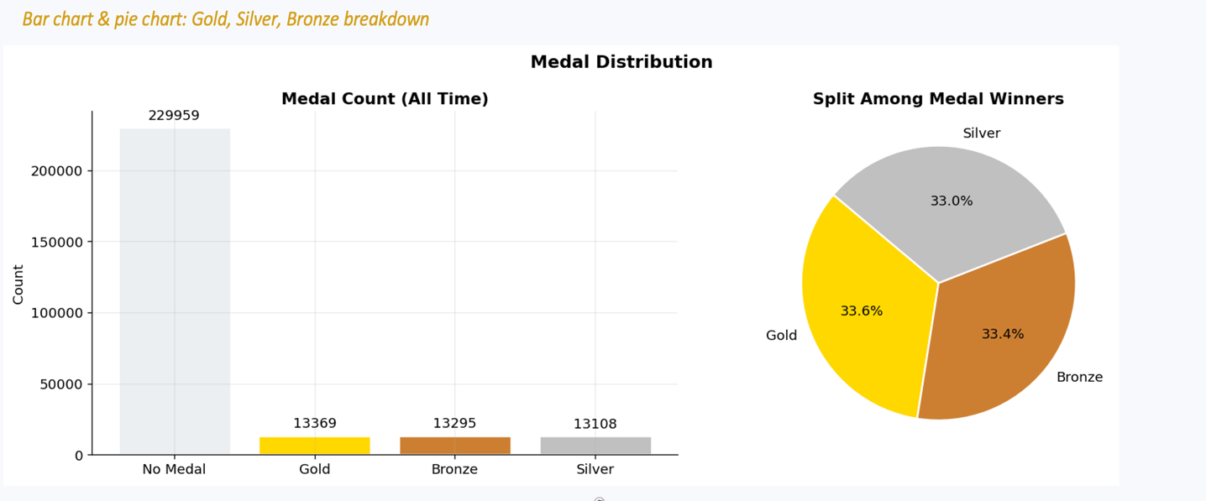

5.3 Sports Participation — Top 20 by Entries
A horizontal bar chart ranked the top 20 sports by total athlete entries. Athletics dominates with over 38,000 entries due to its large number of events (sprints, jumps, throws, walks, marathons, etc.) and long history. Swimming and Gymnastics follow, both having expanded rapidly in the 20th century.

Sports like Tug-Of-War and Polo appear in the dataset but with very few entries, as they were discontinued after the early 1900s. This historical breadth makes the dataset richer but also requires care when comparing sports across eras.

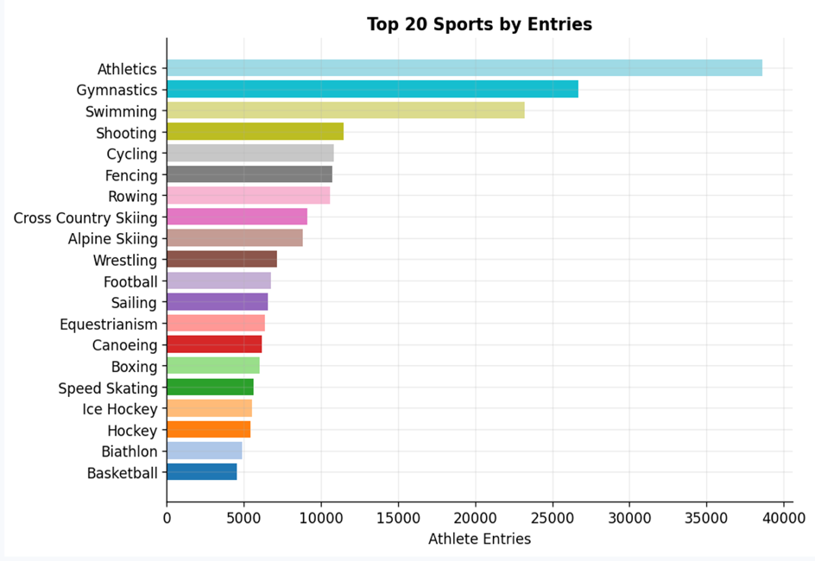

5.4 Gender Participation by Sport
A stacked horizontal bar chart showed the proportion of male vs. female athletes for the top 15 sports. Key findings:
- Gymnastics and Swimming show near-parity, with strong female programmes established since the mid-20th century.
- Athletics has improved significantly, with female track and field events now covering nearly the full programe.
- Wrestling, Weightlifting, and Boxing remain male-dominated, though women's categories have been added in recent decades.
- Shooting shows a surprisingly high female participation rate for a historically male-dominated discipline.
- A vertical reference line at 50% (dashed) was included on the chart to visually identify which sports have achieved gender parity and which still lag behind.

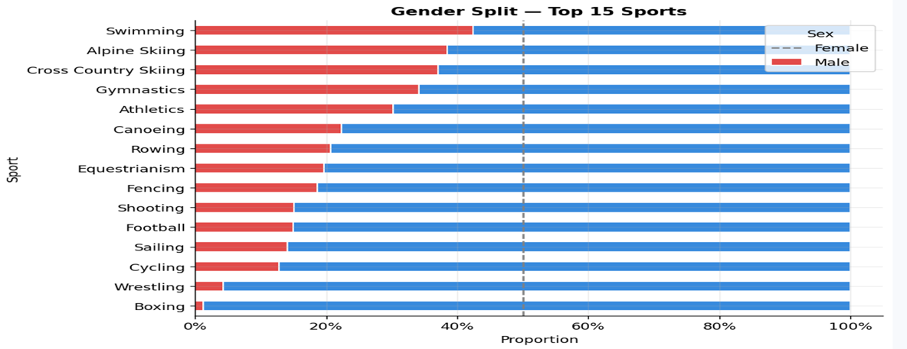

STATISTICAL ANALYSIS

6.1 Descriptive Statistics by Season
Descriptive statistics (mean, median, standard deviation) were computed for Age, Height, Weight, BMI, and Won Medal, grouped by Olympic Season (Summer vs. Winter). The results reveal that Summer and Winter athletes have near-identical physical profiles on average, but differ in medal win rate.

Statistic | Summer — Age | Winter — Age | Summer — Height | Winter — Height | Summer — BMI | Winter — BMI
Mean | 25.49 | 25.03 | 175.40 cm | 174.66 cm | 22.77 | 23.03
Median | 24.0 | 24.0 | 175.0 cm | 175.0 cm | 22.86 | 22.86
Std Dev | 6.31 | 4.76 | 9.59 cm | 7.83 cm | 2.66 | 2.28

The lower standard deviation for Winter athletes in age (4.76 vs. 6.31) suggests Winter Games participants are more concentrated in a narrower age band — likely due to the physically demanding and technically specialised nature of Winter sports such as Skiing, Biathlon, and Figure Skating.

6.2 Medal Win Rate — Summer vs. Winter
The medal win rate (Won_Medal mean) was 0.15 for Summer athletes and 0.12 for Winter athletes. This does not mean Summer athletes are better — it reflects the larger number of events in Summer Games, meaning a higher proportion of the total athlete pool competes in an event that awards medals. Winter Games have fewer events and thus a smaller fraction of athletes win medals per Games.

6.3 Top 10 NOCs — All-Time Medal Count
Medal counts were aggregated by NOC (National Olympic Committee code) to identify the historically dominant nations. The USA leads by a very wide margin, having participated in nearly every Summer Games since 1896 and building a strong national sports infrastructure and elite athlete development pipeline.

Rank | NOC | Country | Gold | Silver | Bronze | Total Medals
1 | USA | United States | 976 | 758 | 666 | 2,400
2 | URS | Soviet Union | 440 | 357 | 328 | 1,125
3 | GER | Germany | 248 | 297 | 300 | 845
4 | GBR | Great Britain | 236 | 272 | 272 | 780
5 | FRA | France | 212 | 229 | 246 | 687
6 | ITA | Italy | 206 | 178 | 193 | 577
7 | SWE | Sweden | 193 | 204 | 230 | 627
8 | AUS | Australia | 147 | 163 | 187 | 497
9 | HUN | Hungary | 175 | 147 | 169 | 491
10 | CHN | China | 201 | 144 | 139 | 484

A grouped bar chart with three side-by-side bars (Gold, Silver, Bronze) per NOC was generated with individual bar labels. This allows direct visual comparison of not just total medals but the quality composition (gold-heavy vs. evenly distributed) for each nation.

6.4 Medal Rate per Athlete — Top Countries
Raw medal counts favour large, long-participating nations. Medal Rate (total medals ÷ unique athletes) provides a fairer comparison of efficiency — how well a country converts athlete participation into medals. Small, high-GDP nations often top this metric.

Country (NOC) | Total Medals | Unique Athletes | Medal Rate
USA | 2,400 | ~5,000 | 0.48
URS | 1,125 | ~2,900 | 0.39
HUN | 491 | ~900 | 0.55
FIN | 302 | ~700 | 0.43
SWE | 627 | ~1,800 | 0.35
CHN | 484 | ~2,000 | 0.24
KEN | 107 | ~500 | 0.21
ETH | 57 | ~300 | 0.19
;
Hungary's exceptionally high medal rate reflects its historic dominance in Fencing, Swimming, and Water Polo — sports where elite technique and tradition translate into consistent podium finishes across generations.
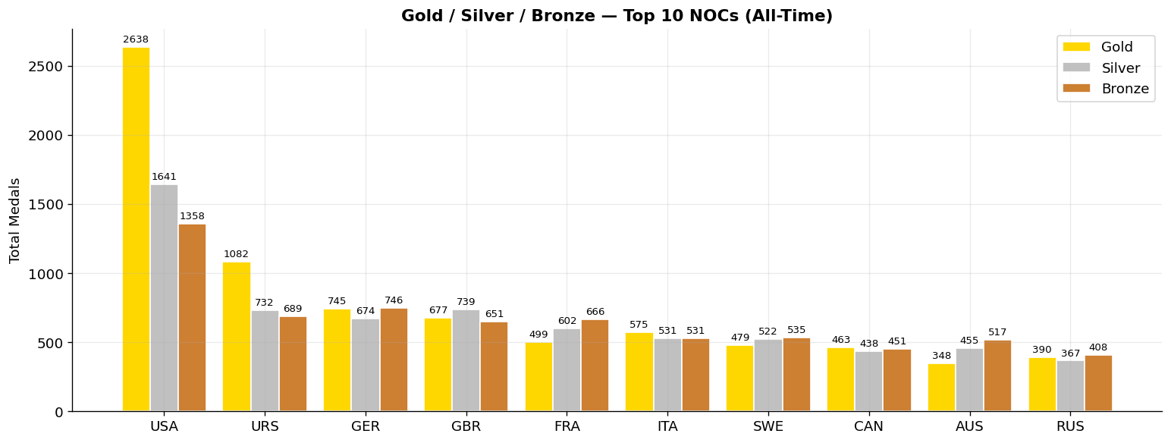
TIME-SERIES & TREND ANALYSIS

Time-series analysis tracks how key metrics evolve across the Olympic years from 1896 to 2016. This section focuses on two major trends: the progression of gender equality in participation, and the shifting dominance of nations on the medal table over time.

7.1 Gender Equality in the Summer Olympics
One of the most significant social stories in Olympic history is the progressive inclusion of women. In the first modern Olympic Games of 1896, women were not permitted to compete. By 1900, a small number of women participated in Lawn Tennis and Golf. Over the following century, the expansion of female events was driven by persistent advocacy and evolving IOC policies.

Year | Male Athletes | Female Athletes | % Female | Key Milestone
1896 | ~241 | 0 | 0.0% | First modern Olympics — women excluded
1900 | ~997 | ~22 | 2.2% | Women compete for first time (Tennis, Golf)
1928 | ~2,606 | ~277 | 9.6% | Track & field events added for women
1960 | ~4,727 | ~611 | 11.5% | Rome Games — first significant female programme
1984 | ~5,263 | ~1,566 | 22.9% | Major expansion; USA boycott affected numbers
2000 | ~6,582 | ~4,069 | 38.2% | Sydney — near-parity efforts intensify
2012 | ~5,892 | ~4,676 | 44.3% | London — every NOC sent female athletes
2016 | ~6,179 | ~5,059 | 45.0% | Rio — closest to parity in history

A stacked area chart was generated showing absolute counts of male and female athletes by Summer Olympics year, overlaid with a line chart of female participation percentage. A horizontal dashed reference line at 50% marks the parity target. The visual clearly shows the accelerating rate of female inclusion since the 1980s.
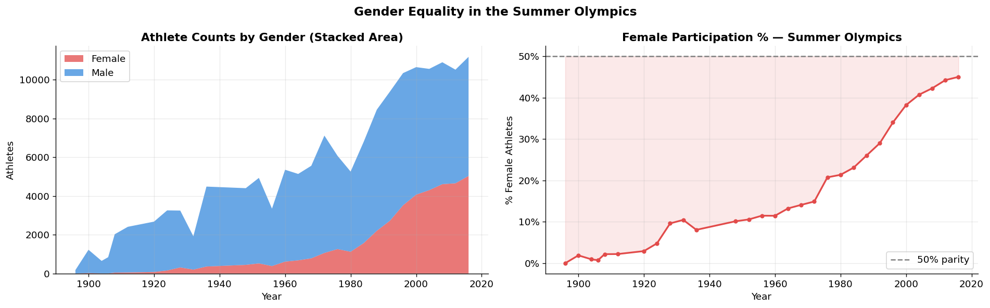
7.2 Medal Dominance Over Time — Top 6 Nations
A line chart was generated tracking the total medals won per Summer Olympics year for the six most decorated nations of all time: USA, URS, GER, GBR, FRA, and CHN. Each nation's trajectory reveals how political, economic, and social forces shaped Olympic performance:

- USA (United States): Consistently the leading nation across almost all Summer Games. Notable dips occur in 1980 (boycott of Moscow Games) when the USA did not participate, and in 1904 (St. Louis) where a large proportion of participants were American by hosting advantage.
- URS (Soviet Union): The USSR entered the Olympics in 1952 and immediately challenged USA dominance. The rivalry intensified through the Cold War era. The USSR's dissolution after 1988 led to its removal from the table, with successor states (Russia, Ukraine, etc.) competing separately thereafter.
- GER (Germany): Germany's medal count shows a complex history — split into two teams (FRG and GDR) from 1968 to 1988. East Germany (GDR) in particular was known for its state-sponsored athlete development programme, which produced exceptional medal tallies relative to its small population.
- CHN (China): China barely features before 1984, reflecting its absence from the Games due to political disputes with the IOC regarding Taiwan. After returning in 1984, China's medal count grew rapidly, reaching its peak at the 2008 Beijing Games (51 Gold medals), driven by massive government sports investment.
- GBR (Great Britain) and FRA (France): Both are historically consistent performers. Great Britain saw a dramatic resurgence post-2000, particularly at the 2012 London home Games, underpinned by the UK Sport 'no compromise' funding model introduced after the 1996 Atlanta Games.
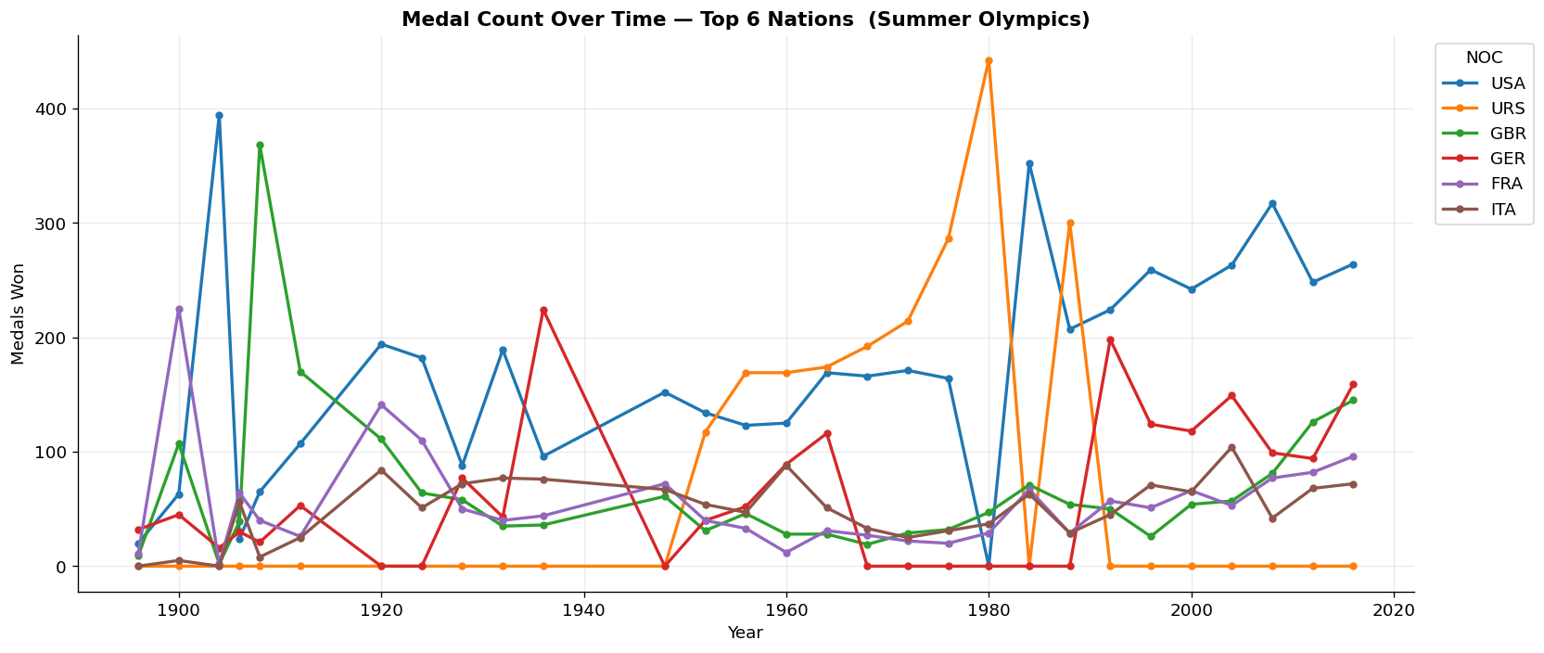
COUNTRY ECONOMICS × OLYMPIC PERFORMANCE

This section investigates the relationship between a country's economic strength (measured by GDP per capita) and its Olympic success. The hypothesis is that wealthier nations should perform better, as they can invest more in sports infrastructure, coaching, nutrition science, and athlete welfare. However, the relationship is more nuanced than a simple linear correlation.

8.1 Building the Merged Dataset
To enable economic analysis, we merged the NOC-level Olympic performance aggregates with the cleaned country economic data. The aggregation computed the following metrics for each NOC across all Summer Games:

Derived Metric | Formula / Source | Purpose
Total_Medals | Sum of Won_Medal per NOC | Absolute Olympic success measure
Gold_Medals | Count of Medal == 'Gold' per NOC | Quality of performance
Silver_Medals | Count of Medal == 'Silver' per NOC | Quality of performance
Bronze_Medals | Count of Medal == 'Bronze' per NOC | Quality of performance
Total_Athletes | Count of unique IDs per NOC | Participation scale
Unique_Sports | Count of distinct sports per NOC | Breadth of programme
Games_Entered | Count of distinct Games labels per NOC | Participation longevity
Medal_Rate | Total_Medals / Total_Athletes | Efficiency / quality indicator

The merge was performed as an inner join on NOC (athlete dataset) and Code (country dataset), yielding 198 matched countries. Three NOCs could not be matched — typically historical or dissolved entities.

8.2 Bubble Chart — GDP vs. Medals vs. Population
A bubble chart was generated with GDP per Capita on the X-axis, Total Olympic Medals on the Y-axis, and bubble size proportional to √Population. Colour coding by GDP Tier (4 colours) makes the economic groupings visually distinct. Key takeaways:

- Strong positive correlation: Higher GDP per Capita nations generally win more medals. The top-right quadrant of the chart (high GDP, many medals) is dominated by USA, GBR, AUS, GER, and Scandinavian nations.
- Population is not destiny: Very large, low-income countries such as India and Nigeria appear as large bubbles near the bottom-left of the chart — high population but few medals — suggesting that population size alone does not generate Olympic success without economic investment.
- Small, wealthy outliers: Several small, high-income nations (e.g., Norway, Cuba, Jamaica) appear as small bubbles with surprisingly high medal counts, indicating that a focused, well-funded sports culture can overcome small population disadvantages.
- China is the most notable outlier: It occupies a unique position as a large-population, upper-mid-GDP nation with extremely high medal counts — achieved through state-directed, targeted investment in medal-potential sports.
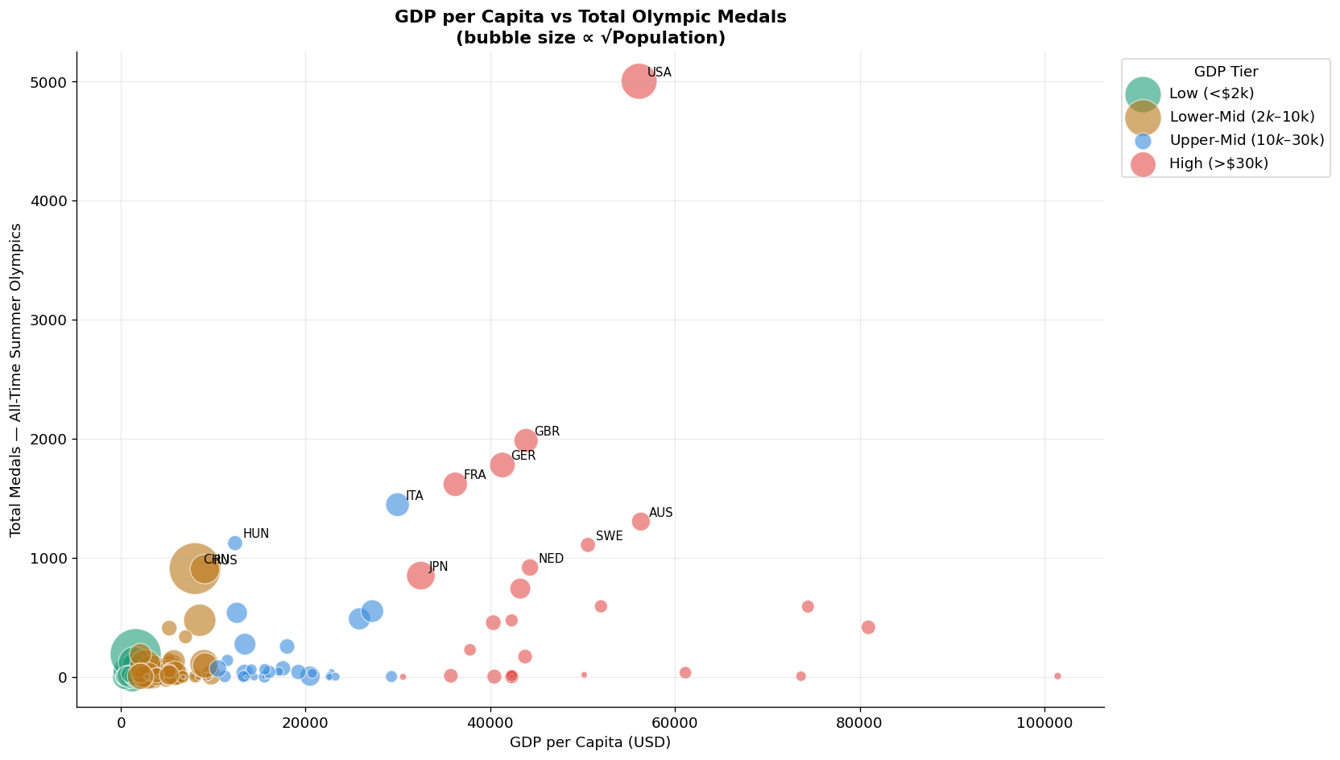
8.3 Medal Count by GDP Tier
Aggregating medal totals by GDP tier provides a clear summary of the economic-performance relationship:

GDP Tier | GDP Range | No. of Countries | Avg. Total Medals | Avg. Medal Rate | Highest Medallist
Low | < $2,000 | ~40 | ~8 | 0.04 | Kenya (KEN)
Lower-Mid | $2,000 – $10,000 | ~70 | ~25 | 0.09 | China (CHN)
Upper-Mid | $10,000 – $30,000 | ~53 | ~80 | 0.18 | Russia (RUS)
High | > $30,000 | ~38 | ~185 | 0.31 | USA

The data clearly shows that average medal counts increase dramatically as GDP tier rises. The jump from Upper-Mid to High is the most dramatic, with High-income nations averaging more than double the medal count of Upper-Mid nations. Medal rate also increases consistently with wealth, confirming that richer nations are not only winning more in total, but also converting a higher proportion of their athlete participation into medals.
CONCLUSION
- Strong positive correlation between GDP per capita and all-time medal count. Wealthy nations invest more in athlete development systems.
- Small high-income nations (Scandinavia, Eastern Europe) show higher medal rates per athlete than large but lower-income countries.
- Female participation rose from near-zero in 1896 to ~45% by 2016, driven by IOC policy reforms. Still ~5% short of parity.
- The USA leads all-time Summer Olympic medals, sustained by private sports infrastructure, college athletics and diverse talent pipelines.
- Post-1984 investment in targeted high-medal sports (diving, gymnastics, weightlifting) made China the #2 Summer power by 2008 Beijing.
- Despite 1.4B population, India has won only 35 Olympics medals — 71% from hockey alone. Medal rate is among the world's lowest.
- BMI and sport match significantly affect medal probability. Sports-specific training programs need physical profiling from youth level.
- India's switch from natural grass to artificial turf in 1980 eliminated its key competitive advantage, causing a multi-decade medal drought.

POLICY IMPLICATIONS

Sports Budget Increase
Raise sports ministry allocation to 0.5–1% of GDP. Benchmark: China spends ~$500M annually on elite athlete programs alone.
TOPS Expansion
Scale up Target Olympic Podium Scheme (TOPS) from ~250 to 2,500 athletes. Include grassroots identification, not just established names.
Sport Diversification
Reduce dependence on Hockey. Invest heavily in Shooting, Wrestling, Badminton, Athletics & Boxing where India shows emerging talent.
Gender Inclusion
Mandate 40% female participation funding in all national sports bodies. India's female medal share is below even global developing-nation averages.

